CTF Project Documentation

LOCAL SETUP FOR UI

**Steps to follow:**

# Project setup – UI

**CT**

Step 1: Cloning the project  
🡪links for the repo which needs to be cloned.

1. <https://dev.azure.com/hrblock/GTC-Ireland-DevopsRD/_git/HRBlock.CTF.UI.Web.Tests>
2. <https://dev.azure.com/hrblock/HRB-ContinuousTestingFramework/_git/CTF.UI>
3. <https://dev.azure.com/hrblock/HRB-ContinuousTestingFramework/_git/CTF.API>
4. <https://dev.azure.com/hrblock/HRB-ContinuousTestingFramework/_git/CTF.API.Drivers.RestSharp>
5. <https://dev.azure.com/hrblock/HRB-ContinuousTestgitingFramework/_git/CTF>
6. <https://dev.azure.com/hrblock/HRB-ContinuousTestingFramework/_git/CTF.UI.Web>

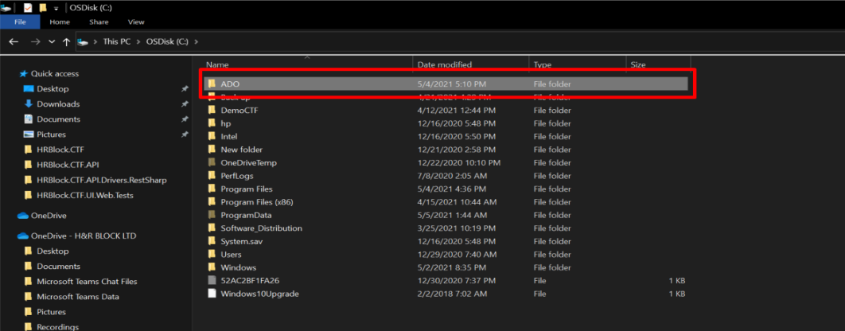Step 2: Create a new folder in a desired location in the file Explorer (Create an internal folder too, if the user has multiple projects). Open the created folder and select “Git Bash Here” from the right click menu.

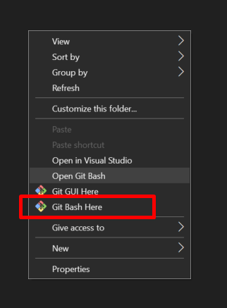

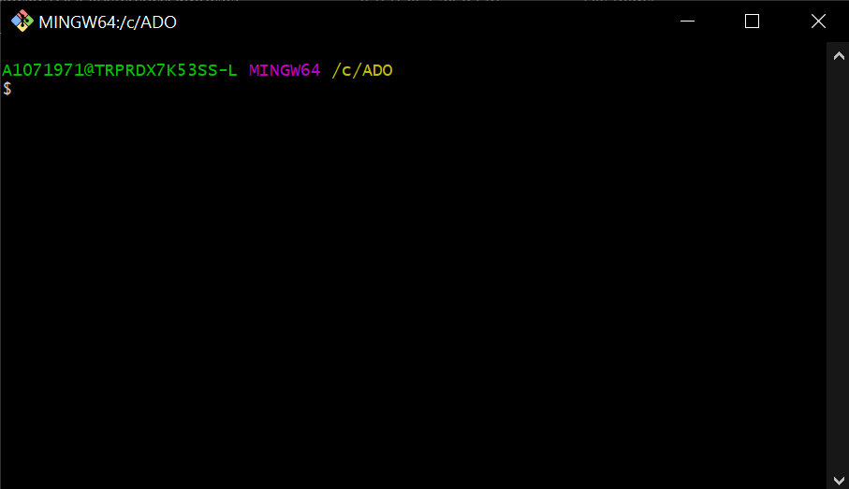

Step 3: Open each links given in Step 1 and take out the repo URL links given in the clone section.

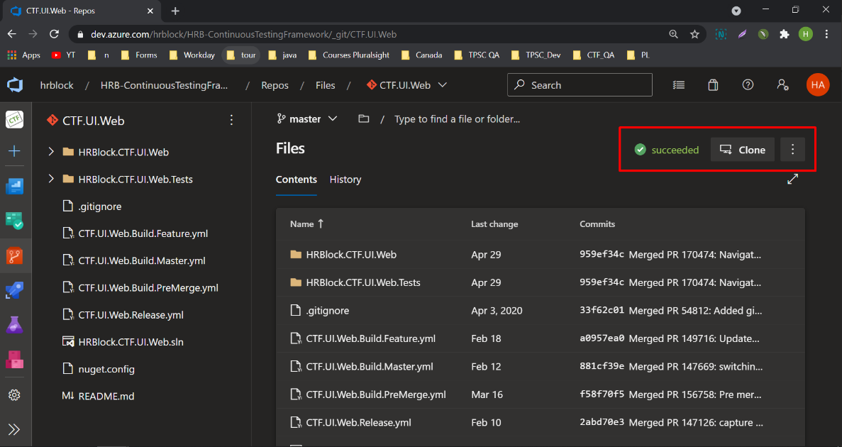

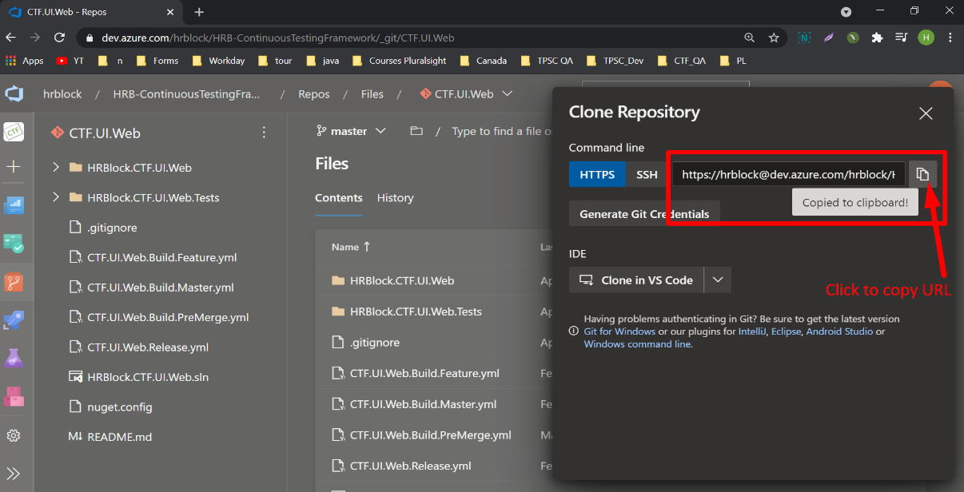

* 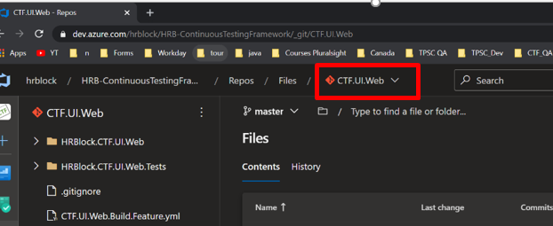In order to swap between project, select the drop-down menu given below.

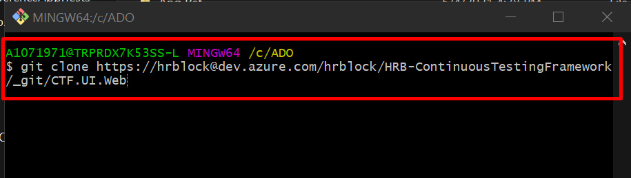Step 4: Open the folder which you’ve created in step 2 then > Git Bash Here – Verify if you are in the right directory and type in ``*git clone*’’ along with the cloned repo link.

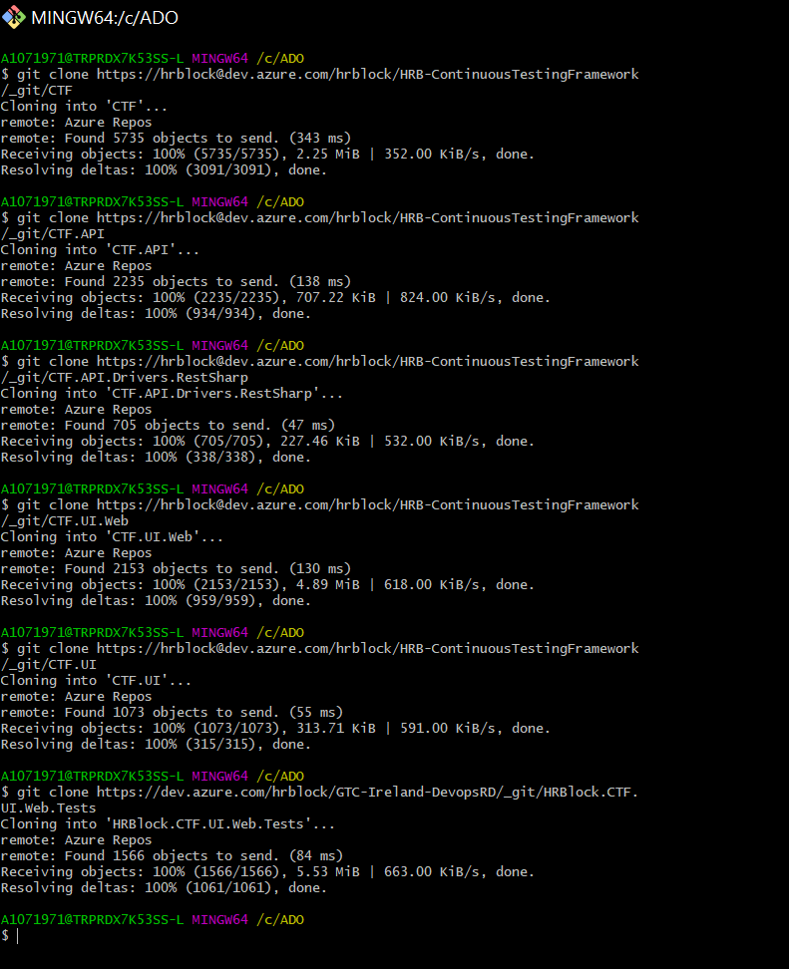Step 5: Follow Step 4 for each links given in Step 1.  
 🡪 Take the links from Step 1 and clone each of them in the same location using the same Git Bash window.

Step 6: Go to the location in the file explorer where the repos are cloned and verify if we have all the files cloned in the location.

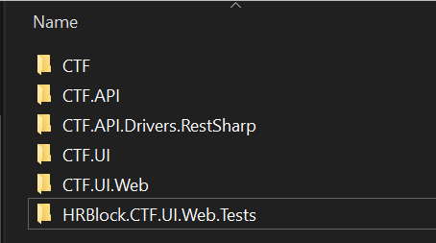

Step 7: Open the folder ``HRBlock.CTF.UI.Web.Tests” 🡪 Click on ``RefAppUITests.sln” to open up the UI solution.

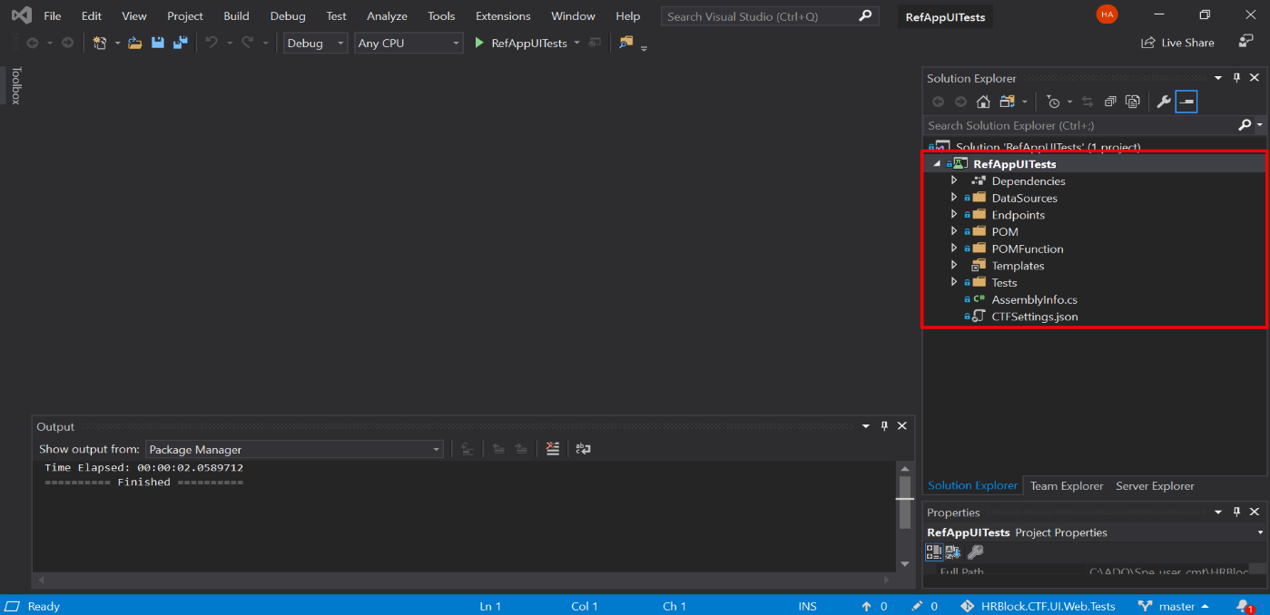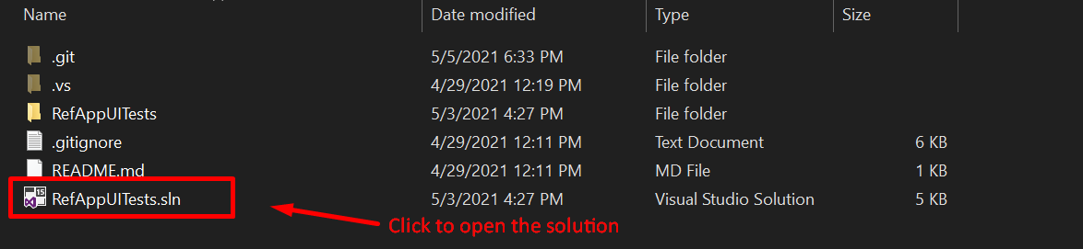Step 8: Opening the UI solution takes you to the Visual studio window.

Step 9: Let’s add other project dependences which are cloned and saved as given in Step 6.

1. Right Click over the Solution ‘RefAppUITests’ 🡪 Add 🡪 Add Existing project
2. Clicking ‘Add Existing project’ will take you to the File explorer where you’ve cloned the repos.
3. Open and add each project from the folders given in Step 6.
4. While adding make sure the user adds corresponding Files (Not the test files)
5. Continue adding projects for all the projects.

* **Below given are the project that needs to be added: User should be adding in total of 6 projects for the main project’s dependences.**

1. CTF: -

Open CTF project through the given path or from the location where user have cloned the repos.

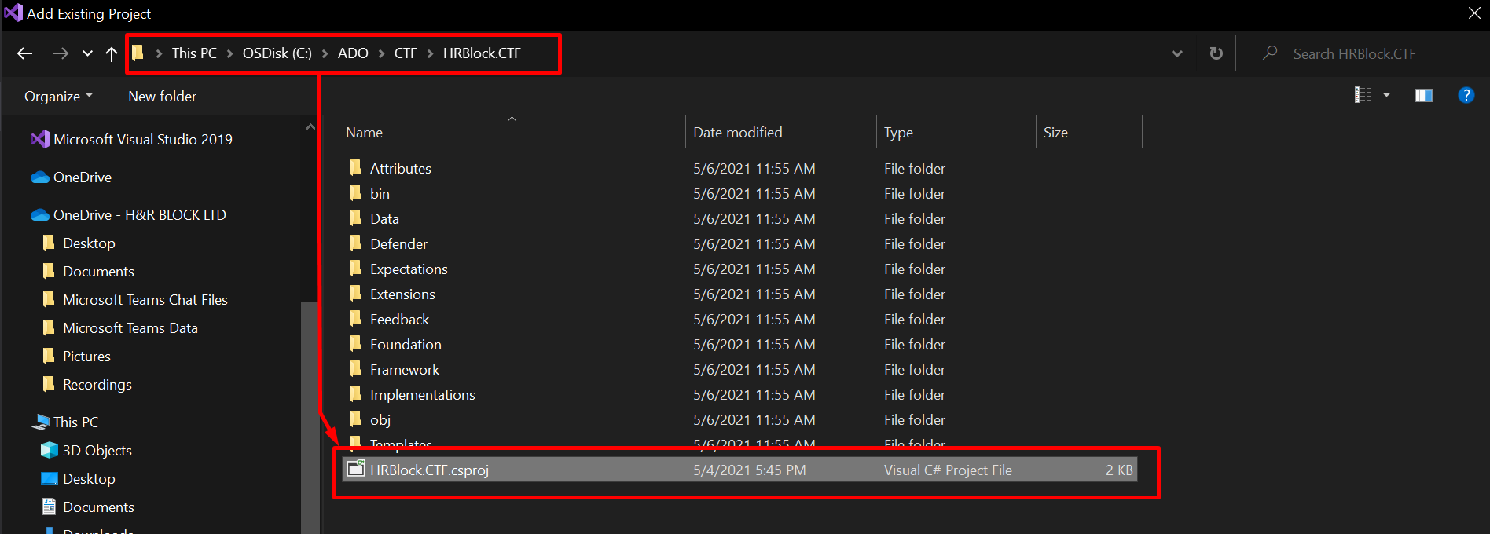

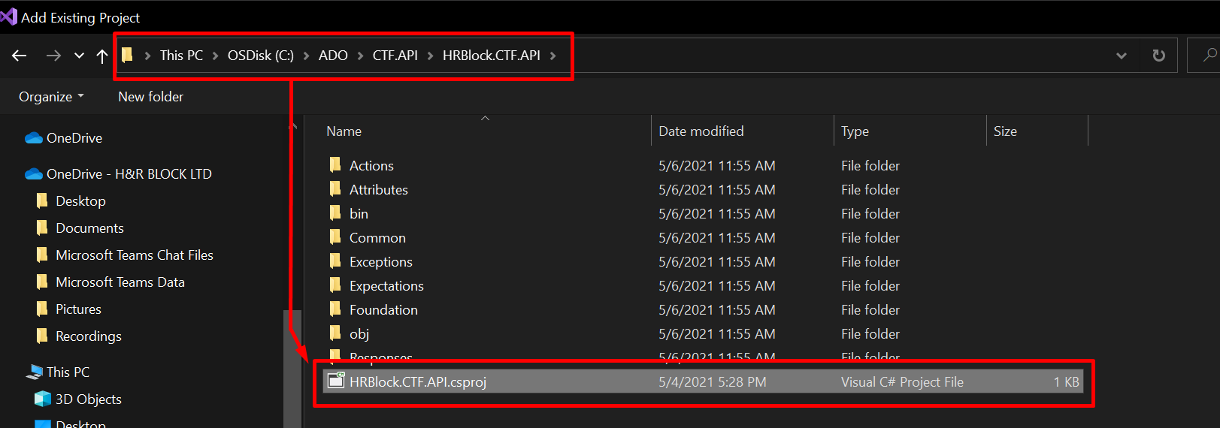2. CTF API: -

3. CTF RestSharp: -

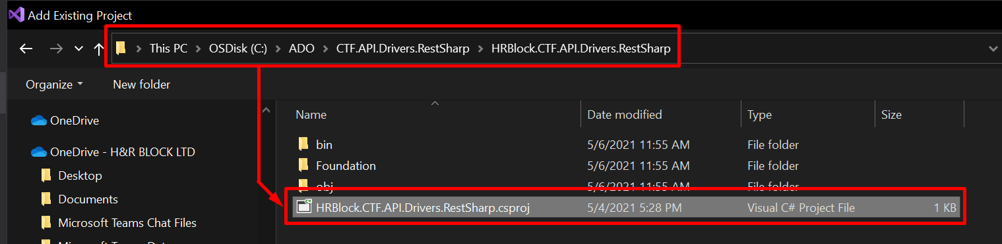  
4. CTF UI:-

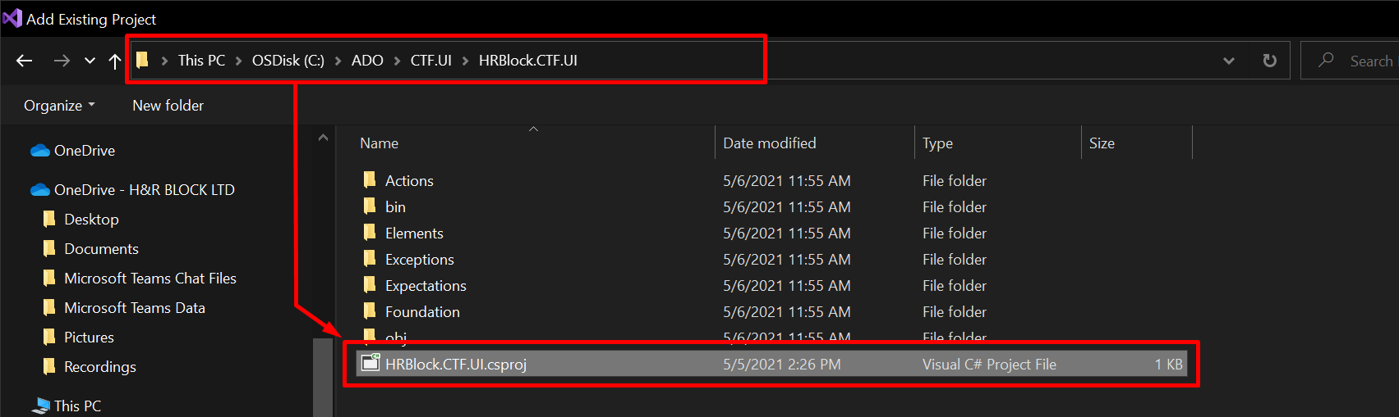5. CTF UI. Web:-

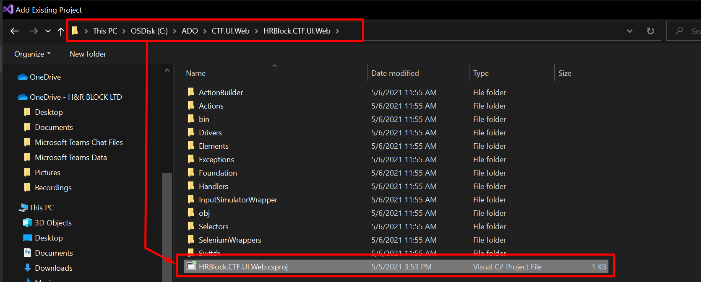

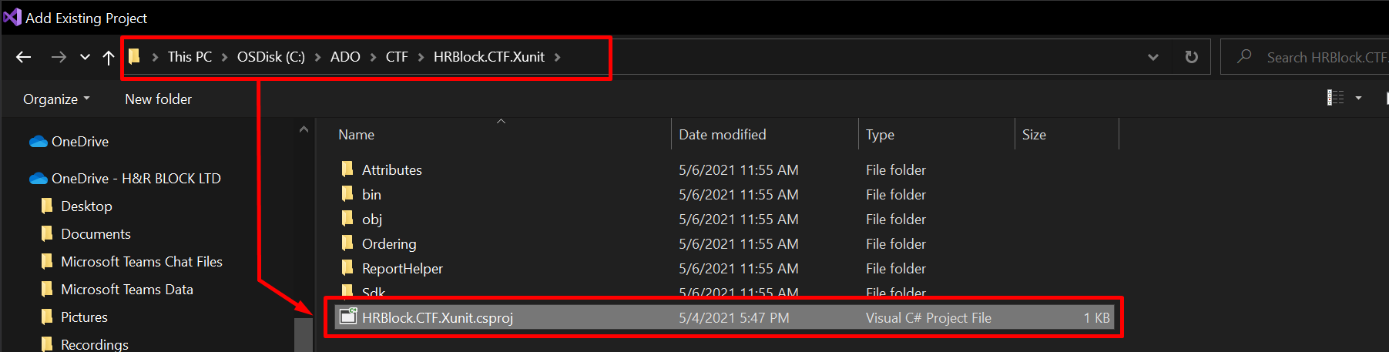6. CTF Xunit:-

1. Verify if user added all the necessary projects files.

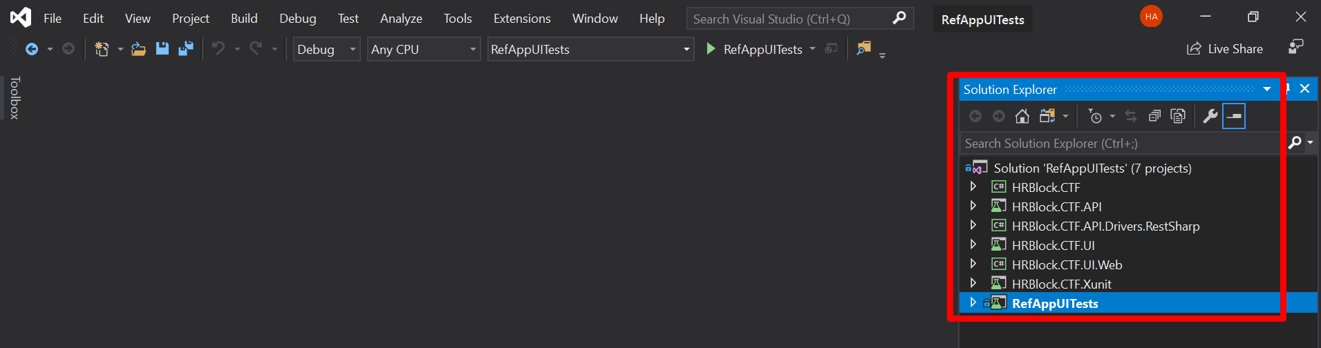   
  
Step 10: The next step is to add references to each project based on their dependencies.

**The steps for adding references to each project are as follows:**

1. Removing default reference: Expand a project 🡪 Dependencies 🡪 NuGet 🡪 Remove in default added reference
2. Adding reference: Expand a project 🡪 Right click on Dependencies 🡪 Add References 🡪 Opens Reference Manager 🡪 Add appropriate Reference needed.
3. In the window that appears check the boxes beside the projects to make the reference.

* RefAppUITests needs to reference HRBlock.CTF.API.Driver.RestSharp and HRBlock.CTF.UI.Web
  + HRBlock.CTF.API.Driver.RestSharp needs to reference HRBlock.CTF.API
  + HRBlock.CTF.API needs to reference HRBlock.CTF
  + HRBlock.CTF.UI needs to reference HRBlock.CTF
  + HRBlock.CTF.UI.Web needs to reference HRBlock.CTF.UI

1. Continue Step 1 and Step 2 for rest of all the project.

Step 11: Adding NuGet packages.

1. Open NuGet manager.

* 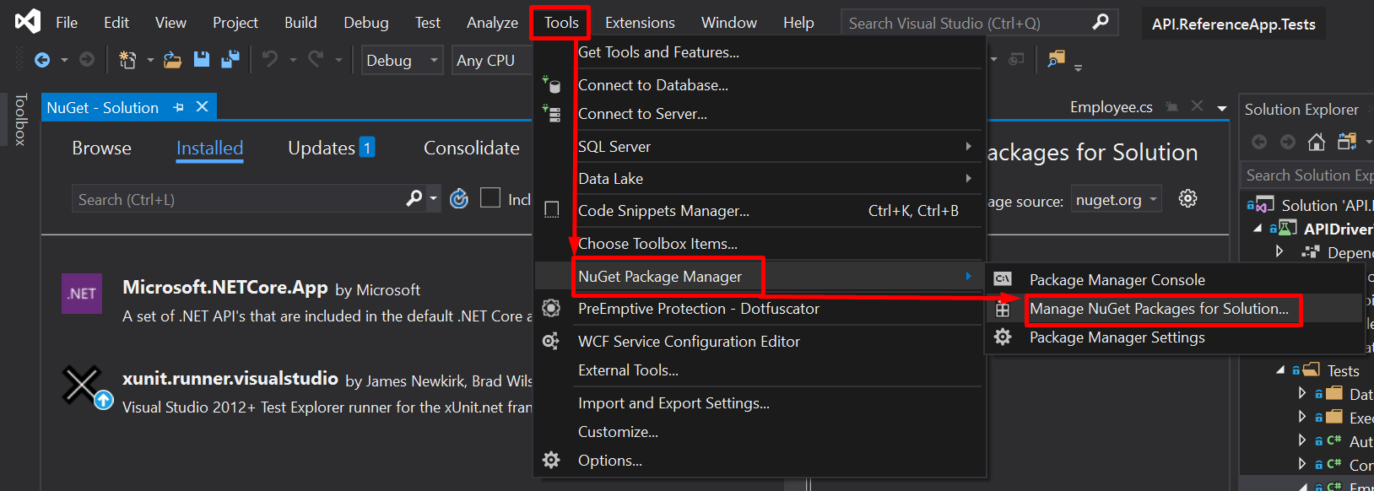Tools 🡪 NuGet Packages Manager 🡪 Manage NuGet Packages for Solution.

1. Adding CTF packages.

* Click on the settings gear icon 🡪 Opens Options menu for adding/managing the packages  
   🡪 Click over the add symbol - **+.**

🡪Add the source as: <https://pkgs.dev.azure.com/hrblock/HRB-ContinuousTestingFramework/_packaging/CTF-Packages/nuget/v3/index.json>

🡪 And change the name as CTF-Packages 🡪 save the added packages by clicking the OK button.

🡪 Select added CTF-Packages as the default package. 🡪 Install all the packages needed from the Browse tab

* Steps for adding CTF packages in NuGet Manager

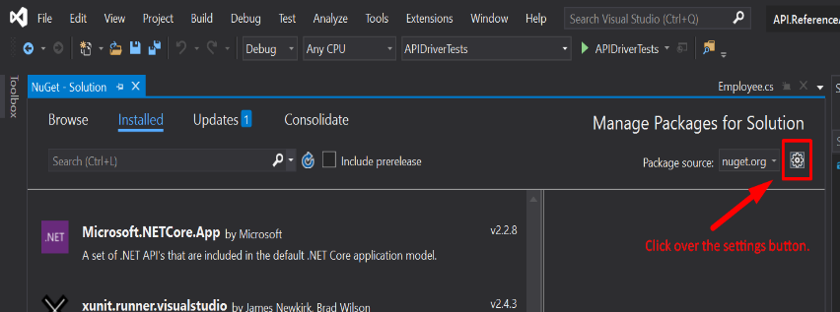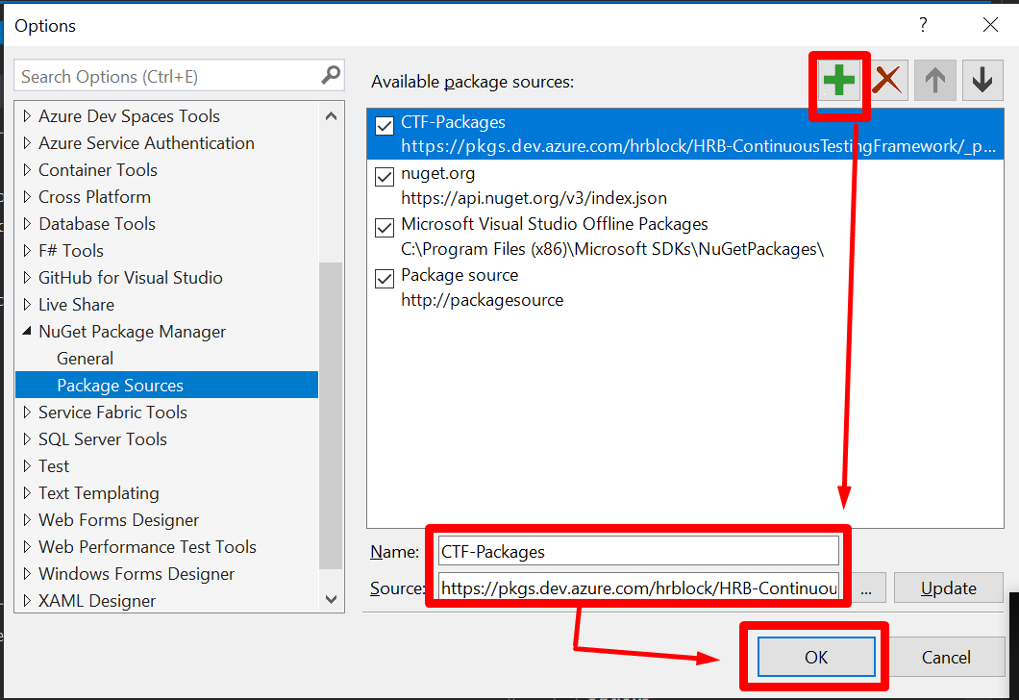

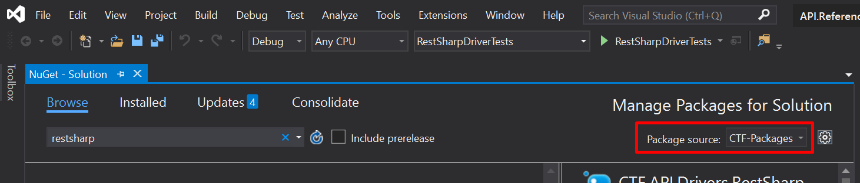

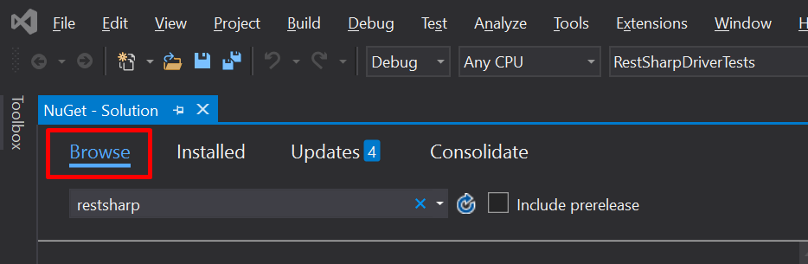

Step 12: In final, Rebuild the project – RefAppUITests to ensure there are no build errors.